**Entity Relationship Diagram for Orders and Products in Company.**

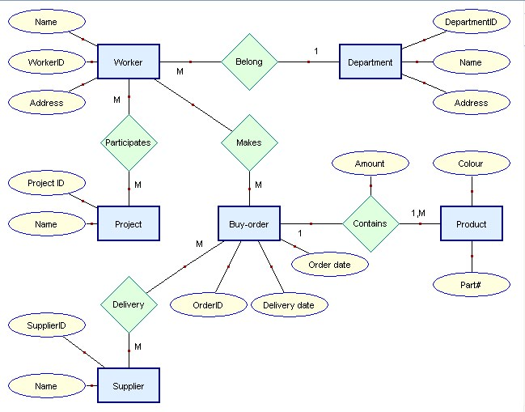

**Entity Relationship Diagram for car repair Company.**

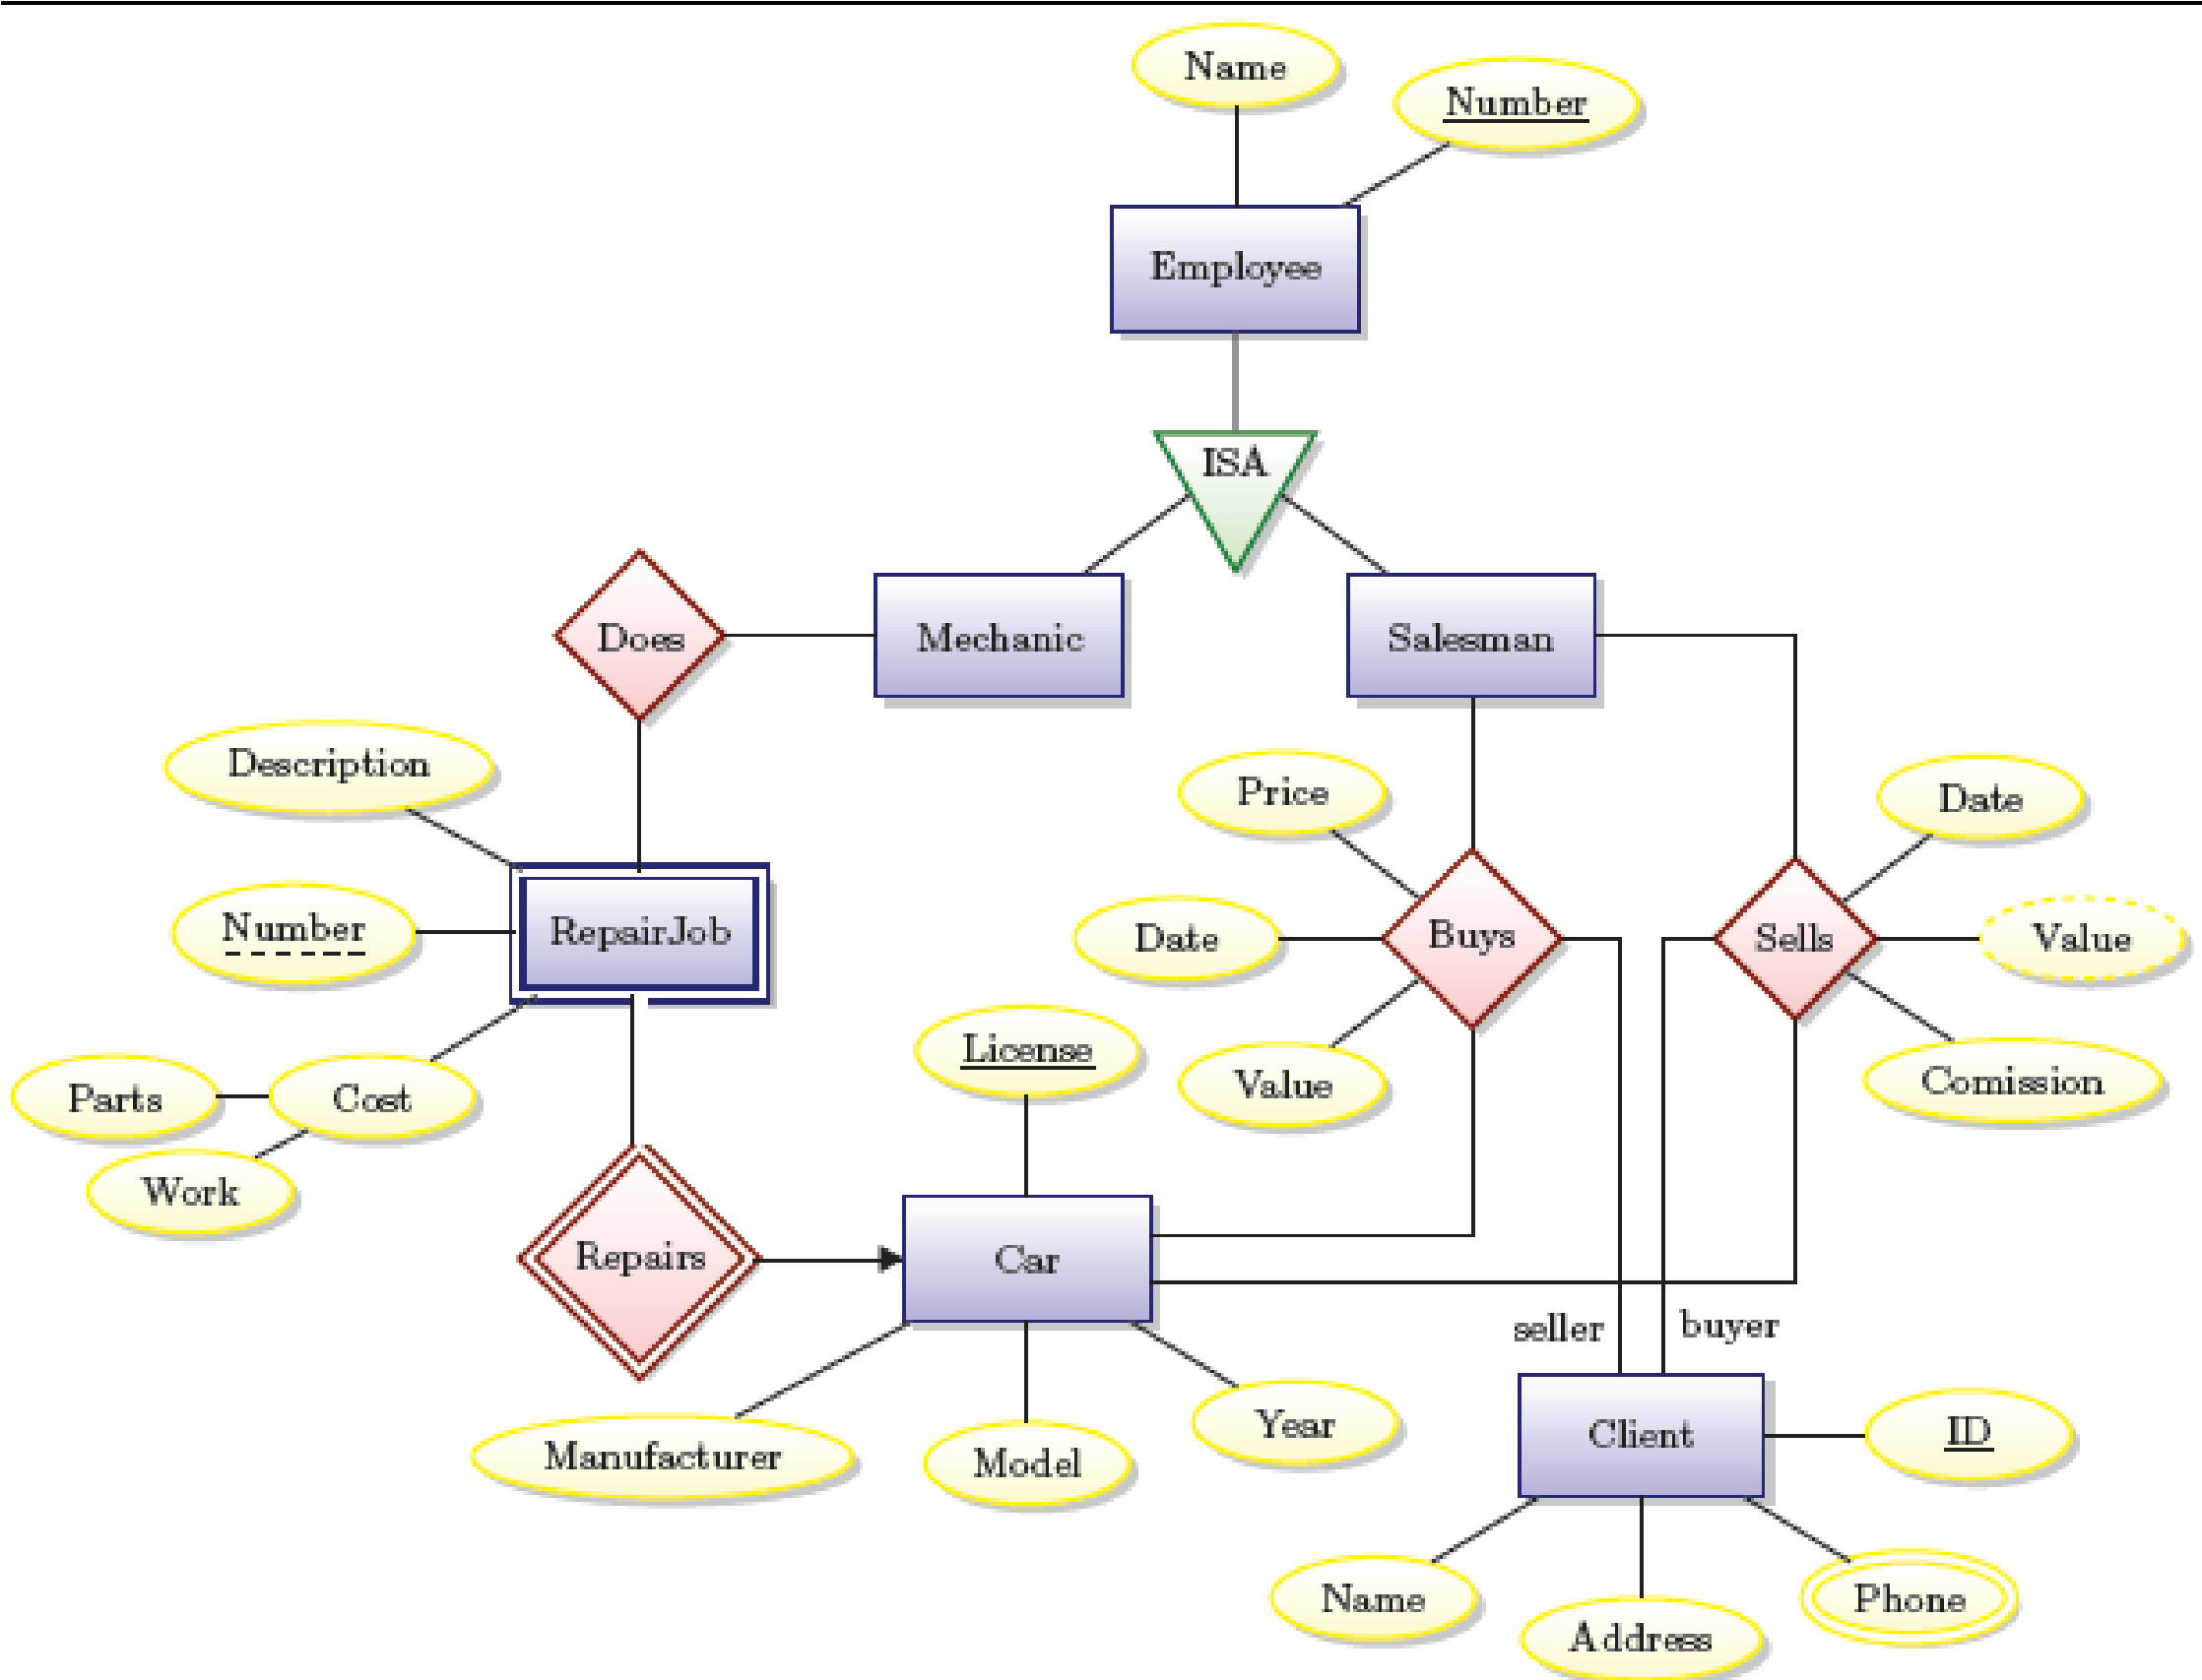

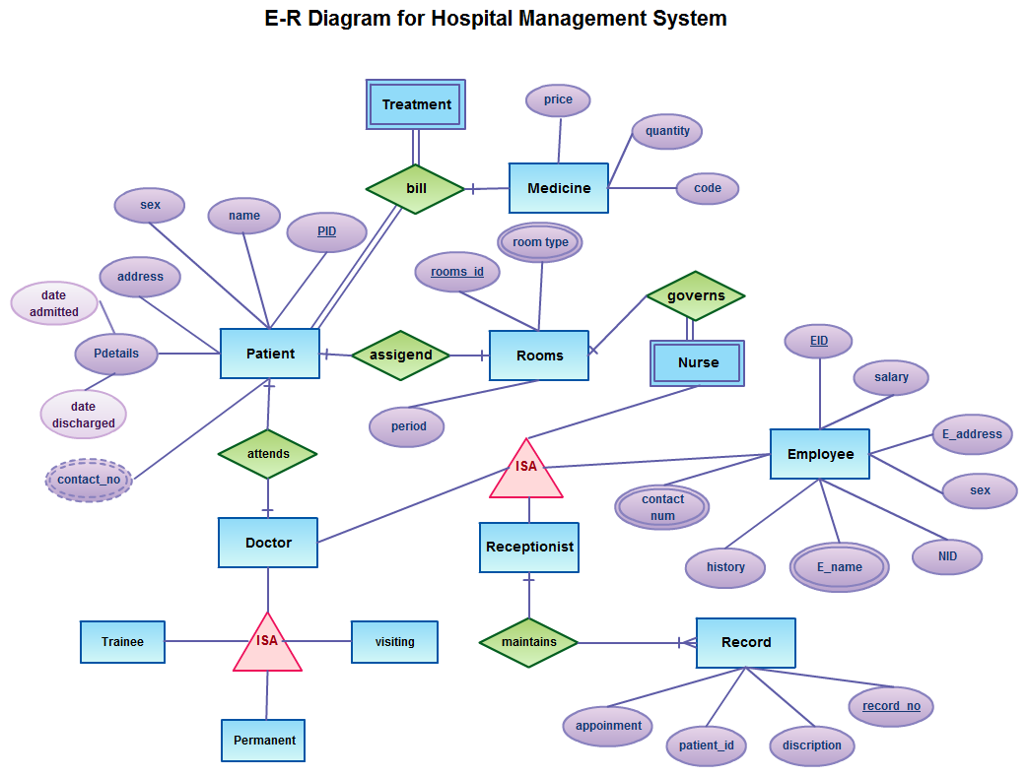

ER diagram of Restaurant management system

